Parth Babbar

IPO (Initial Public Offering) Process & Securities Trading

Initial Public Offering (IPO) Process:
An Initial Public Offering (IPO) is the procedure by which a privately owned firm makes its shares available to the public for the first time. This watershed moment serves many functions: it helps businesses to obtain cash to drive expansion, it increases their visibility and credibility in the market, and it promotes the trading of their shares on public markets. IPOs are key milestones that may generate investor interest, enhance liquidity for current shareholders, and serve as a baseline for future valuation and growth initiatives.
Steps:
- Pre-IPO Planning: Corporate housekeeping include ensuring financial statements, governance standards, and legal compliance. Choosing underwriters requires picking investment banks to oversee the IPO process while managing rules and market realities. Putting together an IPO team of accountants, attorneys, and public relations specialists assures a seamless launch and market reception.
- Due Diligence and Regulatory Filings: Due diligence entails doing a thorough assessment of the company's commercial activities, financial position, and legal standing. The registration statement, which is normally submitted as Form S-1 with the SEC, gives thorough information about the firm to potential investors. Following filing, the SEC performs a review and may make comments that the firm must address and respond to in order for the IPO to move successfully.
- Marketing the IPO: During an IPO, firm management meets with investors in roadshows, while underwriters evaluate demand and establish the IPO price range through book building.
- Pricing and Allocation: The final price of shares in an IPO is decided by investor demand, current market circumstances, and the company's value. Following that, shares are distributed to institutional and individual investors, assuring widespread participation in the offering.
- Going Public: Following an IPO, trading begins on the designated stock exchange, such as the NYSE or NASDAQ, marking the company's public market debut. To retain openness and investor trust, the corporation must follow current SEC standards and meet quarterly reporting obligations.
Challenges:
- Regulatory Difficulty: Navigating onerous SEC laws and compliance obligations.
- Market Volatility: Fluctuating market conditions affect IPO timing and pricing.
- Cost Management: High costs for underwriting, legal fees, and marketing initiatives.
Solutions:
- Regulatory Complexity: Working with skilled legal counsel and consultants to ensure complete preparation and adherence to regulatory norms.
- Market Volatility: Flexibility in timing IPOs to take advantage of favourable market circumstances and modifying pricing tactics in response to investor input.
- Cost Management: Strategic financial planning to optimize expenditures, negotiate competitive service prices, and maximize IPO revenues.
Statistics:
- 1.In 2021, the United States saw around 480 IPOs raise more than $155.8 billion in capital.
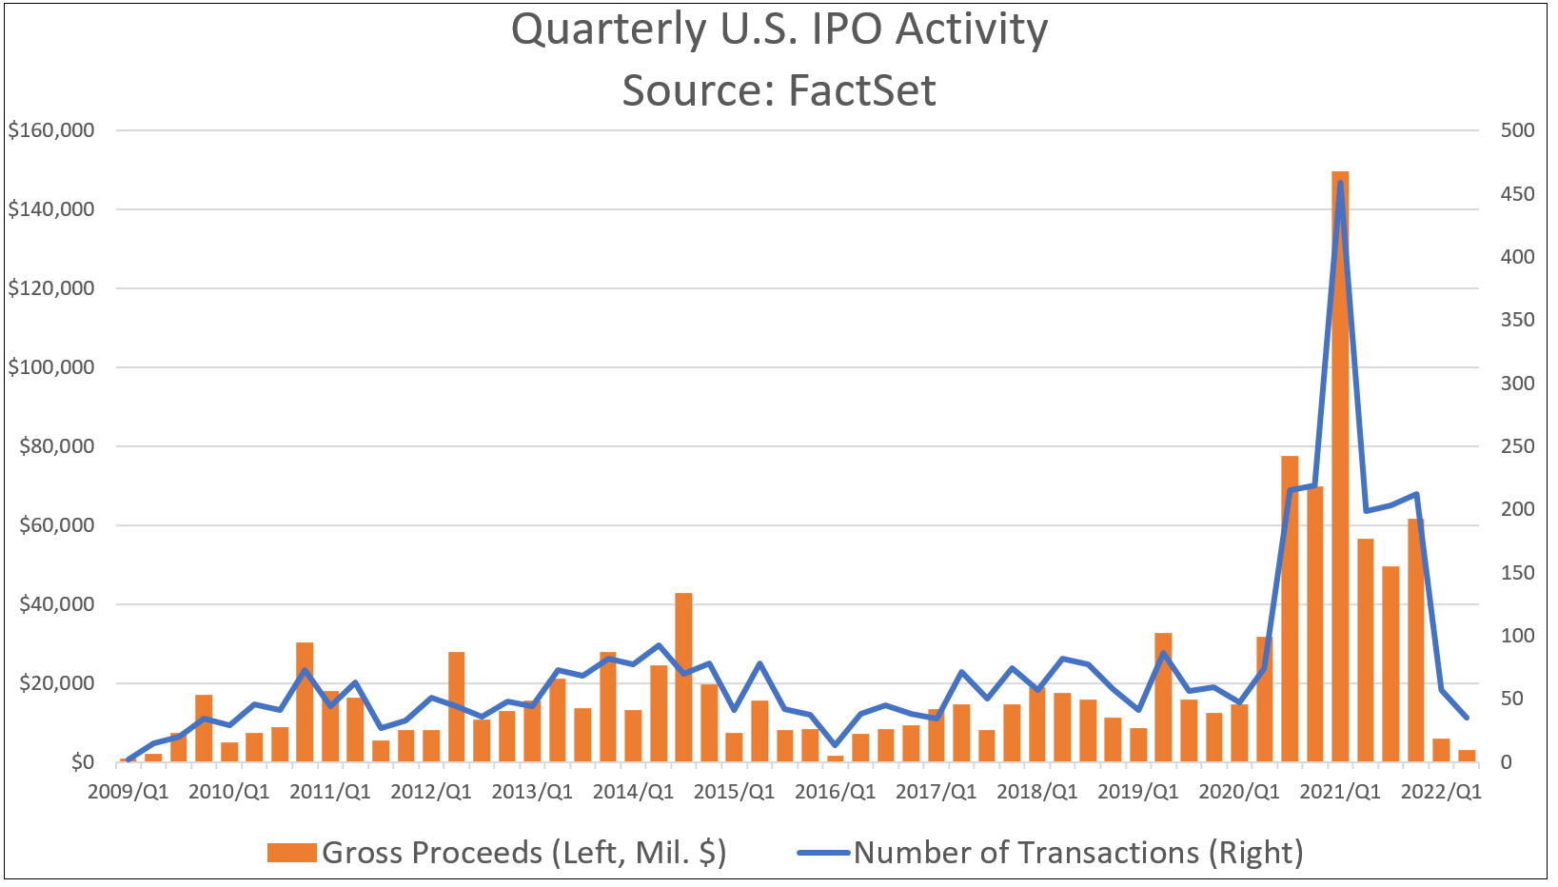
- Major exchanges such as the NYSE and NASDAQ dominate the IPO scene, offering solid venues for new listings.
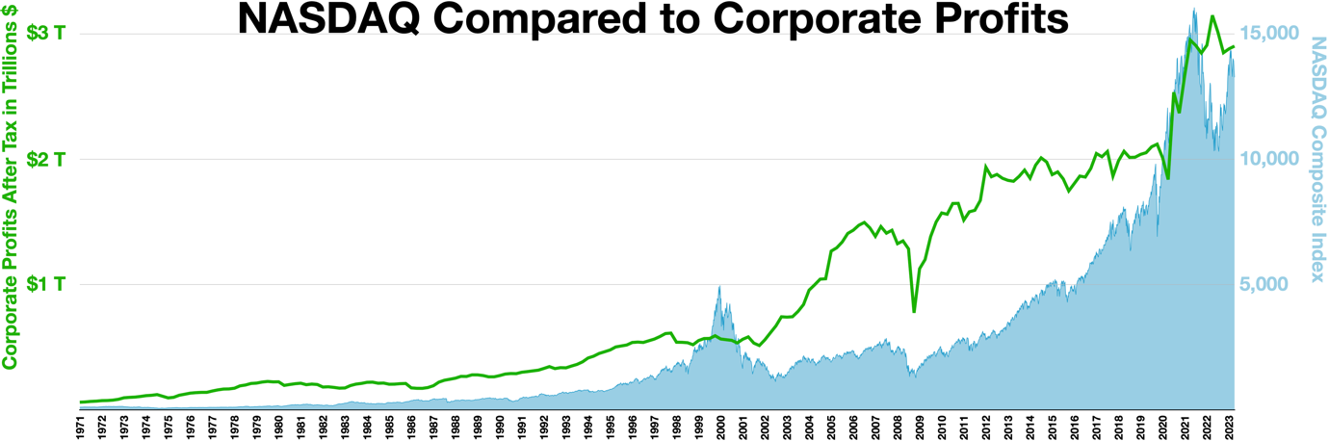
Conclusion:
The IPO process in the United States is a methodically planned journey that transforms private firms into publicly listed corporations. It requires substantial planning, regulatory compliance, and strategic decision-making. Despite its complexity, an IPO provides considerable advantages, including access to financing markets, increased market awareness, and opportunity for growth. Companies planning an IPO face problems such as regulatory restrictions, market volatility, and expensive expenses. Companies may effectively negotiate these hurdles and benefit on the possibilities given by the public markets by hiring competent advice, remaining flexible in scheduling, and thorough financial preparation.
Securities Trading:
Securities trading is the purchase and sale of a wide range of financial products, including stocks, bonds, and derivatives, on various market platforms. This activity is critical for increasing market liquidity, promoting capital formation, and offering investment possibilities for a diverse range of players. Securities trading contributes significantly to global economic growth and financial stability by allowing investors to interact effectively and access a wide range of assets.
Type:
- Stocks: Common stocks give ownership in a corporation, including voting rights and the possibility for dividends based on the firm's success. Preferred equities emphasize dividends above regular stocks, although they often do not contain voting rights. Both types cater to various investor preferences, providing significant benefits in a variety of investing strategies for income and development.
- Bonds: The US Treasury issues government bonds to support government operations, and they are renowned for being low risk. Corporate bonds, which firms issue to obtain cash, vary in risk and yield depending on the company's creditworthiness and market conditions.
- Derivatives: Options are contracts that provide the holder the right to purchase or sell an asset at a certain price within a given time period. Futures contracts commit the buyer or seller to acquire or sell an item at a certain date and price in the future.
Securities Trading Platforms:
- Stock Exchanges: NYSE, NASDAQ, and others offer centralized trading for listed securities.
- Over-the-Counter (OTC) Markets: Enable trading in unlisted securities, including less regulated exchanges such as pink sheets.
Market Participants:
- Retail Investors: Individuals who purchase and sell assets for personal investment.
- Institutional Investors: Mutual funds, pension funds, and insurance organizations that manage large-scale investments.
- Market Makers: Companies that facilitate market liquidity by buying and selling securities.
Trading Mechanisms:
- Market Orders: These orders are executed immediately at current market prices.
- Limit orders: Executed at or above the stated price objectives.
- Stop Orders: Are activated when a security hits a predefined price threshold.
Challenges:
- Market Integrity: Ensures fair and transparent trading activities in the face of possible market manipulation.
- Technological Advances: Handling the effects of high-frequency trading (HFT) on market dynamics and investor trust.
- Cybersecurity Risks: Keeping trading platforms and investor data safe from cyber-attacks and breaches.
Solutions:
- Market Integrity: To ensure market integrity, enhanced regulatory control, effective surveillance methods, and strict adherence to trading regulations are required.
- Technological Advancements: Using advanced trading algorithms, circuit breakers, and risk management protocols to reduce the dangers associated with quick trading operations.
- Cybersecurity Risks: Invest in sophisticated cybersecurity measures, conduct frequent audits, and provide staff training to improve resilience against emerging cyber threats.
Statistics:
- Daily trading volume in the United States is over 10 billion shares, indicating strong market activity.
- The combined market value of the major US exchanges surpasses $40 trillion, demonstrating the size and significance of the US securities markets.
Conclusion:
Securities trading in the United States encompasses a wide range of financial instruments exchanged on platforms such as the NYSE and NASDAQ, which promotes liquidity, capital generation, and investment possibilities for many players. Despite obstacles like as market manipulation and cybersecurity risks, effective regulation and technology protections are critical to guaranteeing fairness and efficiency. Overall, US securities trading is an important part of the global financial system, adjusting to market needs and addressing developing difficulties.
Conclusion:
The IPO process and securities trading are critical components of the US financial markets, allowing for capital generation, investment possibilities, and market liquidity. While both procedures provide significant benefits, they also provide unique problems that must be navigated with careful planning, regulatory compliance, and adaptive tactics. By tackling these concerns through proactive initiatives, technological innovation, and strong risk management procedures, stakeholders can create a resilient and dynamic market environment that promotes long-term growth and investor confidence.

